Tremble Wear

Viable, Versatile Wearable for suppression and nullification of hand tremors

Personal Information

- Name | Dana Vishnu K B
- Qualification | Btech (2021 graduation)
- Designation | Student / Freelancer
- Department | Computer Science
- Year of passing (if alumni) | NA
- Address | 17 A1 Lal Bahadur Colony , Peelamedu , 641004
- Date of Birth | 17 -10 -1999
- Gender | Male
- Mobile | 8883045000
- Collaborating Institutions/industries, if any | NA

B.Introduction to Ideation

Broad Industry sector (Pharma/ Medical Devices/ Biotech/ Other) – Medical

What is your product / service? - It is a viable and versatile wearable that aids in curtailing tremors produced by the Parkinson’s Disease.
What is the idea / innovation? -
Hand tremor influences a huge number of individuals around the world. Tremor is characterized as a unintended, cadenced muscle development.
Tremor negatively affects personal satisfaction, and decreases the ability to perform everyday life undertakings such as eating,drinking, writing, and changing clothing. Some patients with mild tremor do not visit doctors if tremor does not hinder their daily life activities. Their situations often worsen over time. There is currently very few to almost no external solution existing to cope with this medical condition.
OUR OBJECTIVE
"Development of a Viable and Versatile Wearable for Suppression and Nullification of Hand Tremors. "
We propose the development of a glove that is able to dynamically conceive the motion of a user's hand and ascertain the difference between intentional movement and unintentional movement. Further we plan to quantify, verify and attempt to provide haptic response to the users' fingers with the help of coin electroactive polymers to help counteract the unwanted vibration.

Is it an idea or have you validated any proof of concept? b. If you have started any work on it, has it generated any revenue?
We have a Proof of Concept glove readily available with us . We are yet to test this product on actual patients .

Any other information on status of your idea / start-up (in terms of technology) –

OUR PROPOSAL:
We have successfully prototyped our idea - a pair of smart, IoT connected wearable gloves which act to curb/nullify trembling in the hands of the user. The wearable uses a patent-pending AI algorithm to identify and predict unintentional tremors, and provides counter feedback, which stabilises the hands of the user. All the measured data is available to the user through the convenience of an app, and can be used by doctors to provide better treatment.

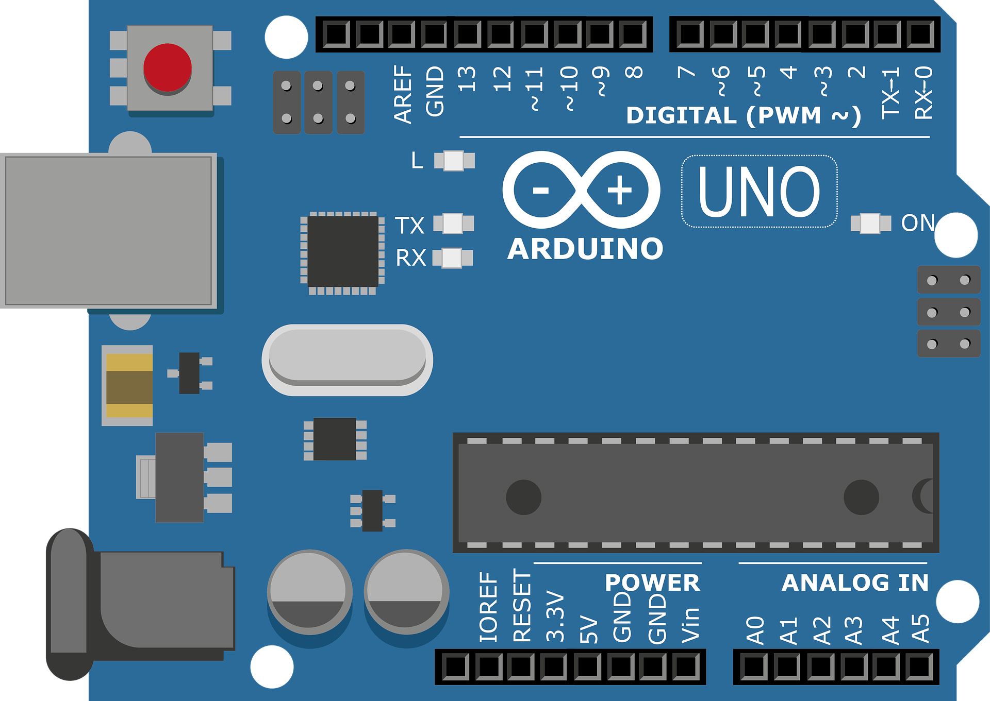
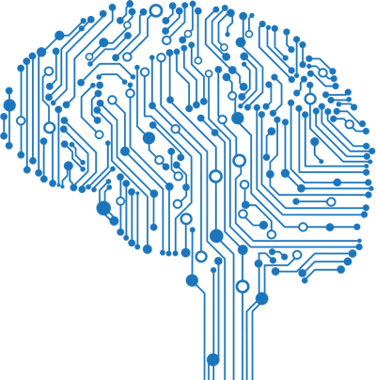
Fig 1 : Block Diagram
Nullification of tremor by shifting phase angle
Gyroscope
Arduino

Machine Learning Algorithm

Electroactive Polymer

Generating electrical pulses according to algorithm results

WHY WE ARE UNIQUE:
Other efforts into solving this problem, to the best of our knowledge is as follows:
Emma Watch - A device made by Microsoft, but not a product, rather only designed for one single person (Emma Lawton)
GyroGear - A promising product in theory, but has been in development for over 10 years.
Parkinson’s spoon - While effective, it is limited to only one activity - eating.
We have combined the best of all these products, and used cutting-edge technology to overcome the problems faced by the previous attempts .

OUR PROGRESS
Mark 1
Designed and implemented the AI algorithm, minimum viable cloud connectivity and app prototype. Hardware was configured with the help of a breadboard and custom software was tested on it. Counter frequency is provided by coin motors.
Mark 2
Following the lessons learnt from making our first prototype, we further improved our algorithm to achieve extremely high accuracy of tremor prediction. The hardware was soldered together, and the entire setup is more robust. Cloud connectivity was established via a real time uplink, and user dashboard was implemented. Due to lack of availability of EAP, this model too is powered by coin motors.

OUR VISION:
We envision a sleek, affordable wearable glove, made with Electroactive Polymers and state-of-the-art mobile computing technology. We believe that this product would be invaluable to every person who is affected by hand tremors, and would greatly improve their quality of life.

What is the problem you are trying to solve?
Hand tremor influences a huge number of individuals around the world. There is currently very few to almost no external solution existing to cope with this medical condition. We plan to develop a device that helps in controlling and curtailing the tremors produced by hand tremor related diseases ,

What experiments you will like to do?
We are in talks with setting up a camp at Amrita Institute Of Medical Sciences which is affiliated with our university. We plan to test the glove on patients at the hospital , record their feedbacks and effectiveness of the product . With all these metrics measured we plan to release a more reliable beta build .

What will be requirement to get idea conceptualised?

1. Funding for purchase of necessary equipment which include the processors, connectors.
2. Funding towards software purchase.
3. Funding for trial run and testing.

C. Strategy

What if you do not get incubation support from DIIF?
We are hopeful to get the financial support and mentorship from DIIF. If unfortunately not, we will maintain a positive outlook and still relentlessly pursue our dream of making this product a reality .

What if you get incubation support from DIIF?
Immediate step would be to strategize the testing plan followed by the strategization plan for the project , and to finalize the schedule for the beta version release of the product.

How do you plan to scale up your start-up?
To our understanding and study results additionally uncover that, the item is one of a kind in the entirety of its highlights. Both broadly and universally the item will have part of extension. Before productizing, we will do a preliminary pilot run by connecting the emergency clinics in volume, take the input and turn out with strong, completely useful, industry prepared arrangement. This would require time and coaching from DIIF specialists.

What are the challenges you are facing now and you foresee in next 2 years?
- Getting permissions for testing the product .
- Making the product feel less intrusive by making required design changes .

D. Requirements
1. Funding of Rs. 5 Lakh towards the hardware and necessary components procurement.
2. Mentoring from Medical Experts on Zeroing in the design.
3. Funding of Rs. 5 Lakh for the miniaturization, travel and testing.

E. Abstract / Summary of proposal (Maximum 200 words):

We propose the development of a glove that is able to dynamically conceive the motion of a user's hand and ascertain the difference between intentional movement and unintentional movement. Further we plan to quantify, verify and attempt to provide haptic response to the users' fingers with the help of coin electroactive polymers to help counteract the unwanted vibration.

Currently there are 10 million people in the world affected by Parkinson's . We believe that our product shouldn't just die on the drawing board, but instead should be out there, impacting real lives and we want to play our part in making the world a better place .

