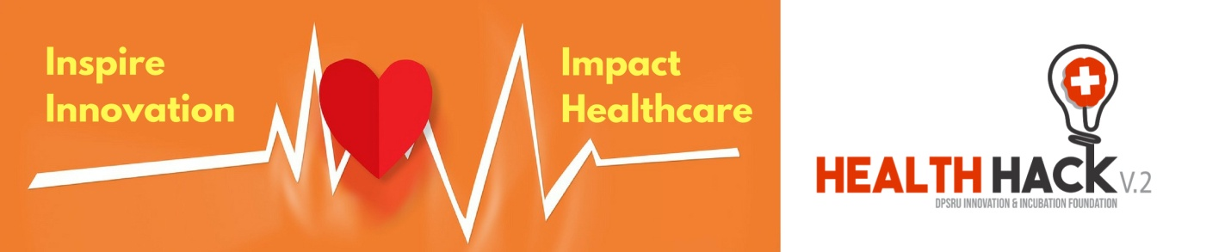

A. Personal Information
- Name: DEEPAK RAJ
- Qualification: GRADUATE
- Designation (Student/ Faculty/ Alumni/ Any other): Entrepreneur
- Department (if student): NO
- Year of Passing (if alumni): NO
- Designation (if faculty): NO
- Address: 10104 ,TOWER D1 , GH7 CROSSING REPUBLIC ,GHAZIABAD ,UP 201016
- Date of Birth: 25 NOV 1985
- Gender: MALE
- Telephone, mobile, fax and email : 8588856779 ,8207482110 , deepakraj252002@gmail.com
- Collaborating Institutions/industries, if any -NO

B. Introduction to Ideation
- Broad Industry sector (Pharma/ Medical Devices/ Biotech/ Other) - PHARMA
- What is your product / service? – A medicated herbal chewing gum to prevent lung/lever problem that generated by smoking and it help to repair your lungs, throat and liver with smoking/drinking habit.

- Who is recipient / beneficiary of your product / service? –Smoke addicted and people who are affected by the air pollution.
- What is the idea / innovation?
a) Is it an idea or have you validated any proof of concept?
- The ingredients which are use to make this herbal chewing-gum are using in most of verified anti-smoking/lung repairs herbs and they all are already verified.

b) If you have started any work on it, has it generated any revenue?
- Product is ready, but not introduce in market

- Any other information on status of your idea / start-up (in terms of technology)
- What is the problem you are trying to solve? - Smoking causes 43 %death due to lung cancer , try to prevent the lungs and liver problem that generate by smoking . it help to repair lungs and liver with smoking habit
- What experiments you will like to do? – lab testing , and clinical test in different areas of country
- What will be requirement to get idea conceptualised? - Clinical test. market research and review for different part of india , licences as requirement
C. Strategy
- What if you do not get incubation support from DIIF? - As I’m eagerly looking for Incubation centre to start my entrepreneurial journey and if I’m unable to get this opportunity, I’ll try to find other ways to start this business.

- What if you get incubation support from DIIF? – Indeed! It would be a wonderful opportunity for me and I’ll be glad to be part of DIIF. I’ll give my fullest to make my business successful.

- How do you plan to scale up your start-up? - I’m working on social issue and there are a number of people who’re smoke addicted. My product comes into soft manufacturing process, so I would set up a factory and try to capture market by social campaigns etc.

- What are the challenges you are facing now and you foresee in next 2 years? -Right now I’m lacking with R&D facility, Infrastructure and financials which certainly I’ll get here to be part of DIIF Incubation Centre.

D. Requirements
- Infrastructure required (Workstation / Office space / Lab facility / Internet facility / Labs / Animal house) – workstation , office space , lab facility , internet facility ,lab
- Justification of infrastructure required- office space & work station for interners and promotional marketing on online platform & social media . feedback call operator , lab testing of improving the power of medicine , meeting room required for market tie- up meeting and meeting with distributor
- Requirement of meeting room (Frequency of meetings being held / month): - 4 to 5 times in a month
- Funds required upto 2 years: - 40 lack
- Assistance required upto 2 years:- 2 years

